DBMS Practical-1:
i) Hospital Management System: A multi-specialty hospital is facing inefficiencies in maintaining patient records, doctor schedules, lab reports, and billing due to scattered and redundant data across departments. A centralized DBMS is required to ensure that medical staff can access up-to-date patient information, test results, and treatment plans securely and in real time. The system should also manage appointment bookings, room allocations, and pharmacy inventory while ensuring strict compliance with privacy and security protocols like HIPAA or local equivalents.

Entities & Attributes:
1. Patient (Patient_ID, Name, DOB, Gender, Contact, Address)
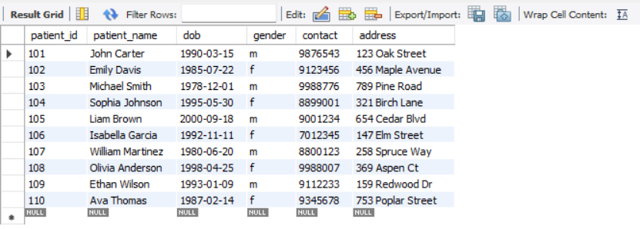
2. Doctor (Doctor_ID, Name, Specialization, Contact)
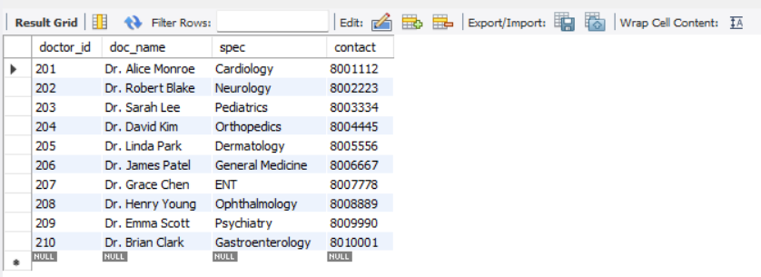

3. Appointment (Appointment_ID, Patient_ID, Doctor_ID, Date, Time, Status)
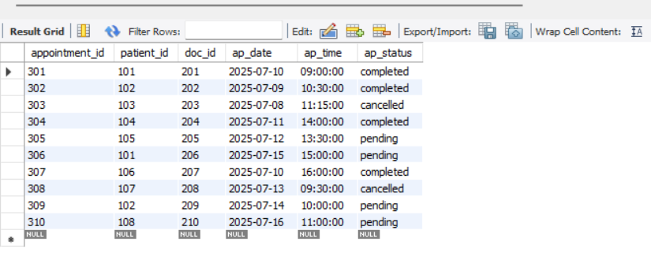

ii) Car Rental Company: A car rental company is experiencing difficulties managing reservations, vehicle availability, and customer records across multiple branches. A DBMS is needed to centralize all vehicle data, including model, condition, rental rates, and current status, and to coordinate with customer reservations to prevent overbooking. It must also maintain rental history, calculate charges based on duration and car type, and provide management with analytics on fleet utilization and maintenance schedules.

Entities & Attributes:
1. Customer (Customer_ID, Name, License_Number, Contact)
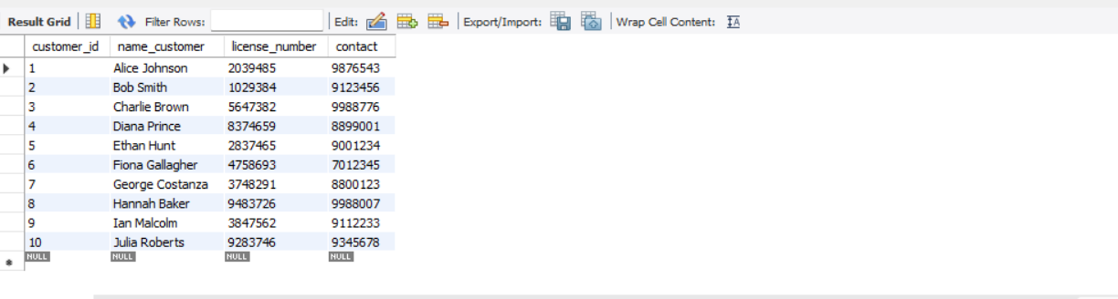
2. Car (Car_ID, Model, Category, Manufacturer, Availability_Status)
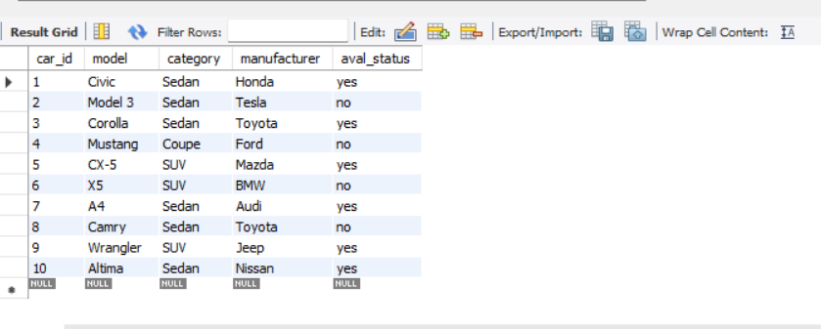
3. Rental (Rental_ID, Customer_ID, Car_ID, Rental_Date, Return_Date, Total_Amount)
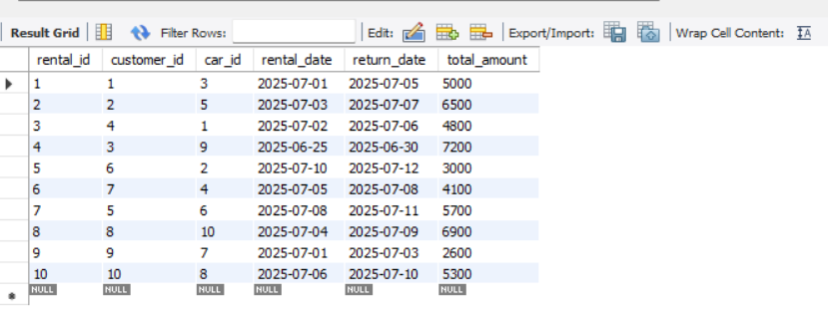
4. Staff (Staff_ID, Name, Role, Contact)
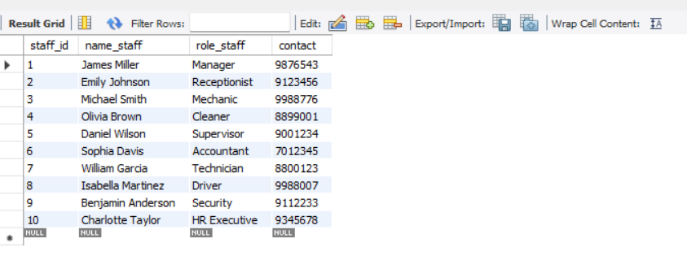

iii) Hostel Room Allocation: A university hostel housing hundreds of students is facing challenges in allocating rooms fairly and efficiently each semester. The current manual process often results in double allocations, mismatched preferences, and inaccurate occupancy records. A DBMS solution is needed to manage student profiles, room details (type, capacity, occupancy status), and allocation history. It should support automatic matching based on criteria like gender, course, and year, and allow wardens to update check-in/check-out dates and view real-time availability reports.

Entities & Attributes:
1. Student (Student_ID, Name, Gender, Course, Year)
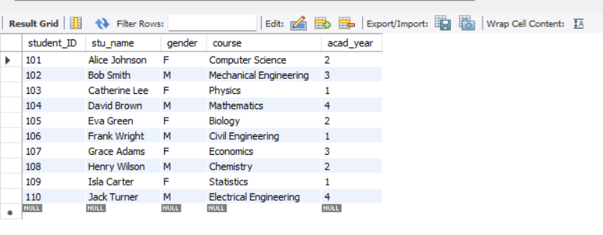
2. Room (Room_ID, Room_Type, Capacity, Occupancy_Status)
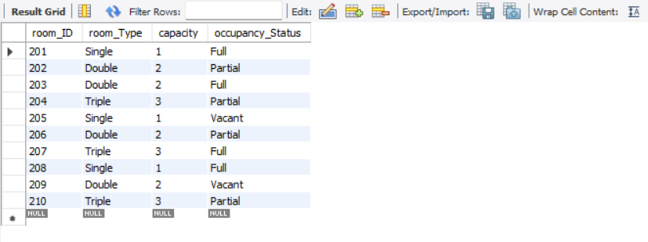

3. Allocation (Allocation_ID, Student_ID, Room_ID, CheckIn_Date, CheckOut_Date) 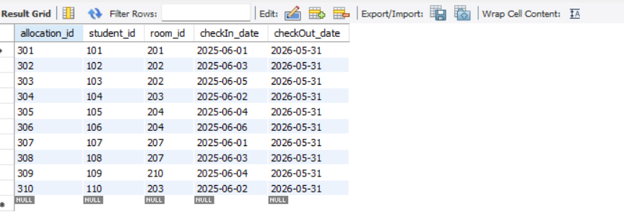
iv) Library Management System: A large academic library needs a robust DBMS to manage thousands of books, multiple categories, and hundreds of daily users. The current manual or semi-digital system struggles to track borrowings, returns, and due dates, often resulting in misplaced books and user dissatisfaction. The DBMS must handle user registrations, book check-ins and check-outs, fine calculations, and provide fast search and filtering by title, author, genre, or availability. It should also support generating usage reports and sending automated notifications for overdue items.
Entities & Attributes:
1. Book (Book_ID, Title, Author, Publisher, ISBN, Category, Copies_Available)

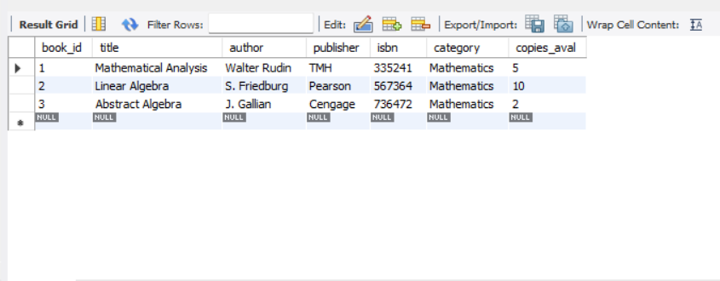
2. Member (Member_ID, Name, Department, Membership_Date, Contact)
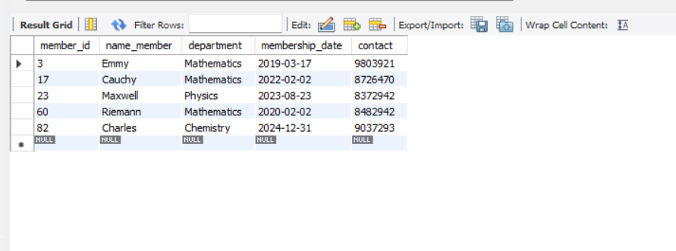
3. Transaction (Transaction_ID, Book_ID, Member_ID, Issue_Date, Return_Date, Fine)
